Table of Contents

**Navratri: Nine Nights of Divine Feminine Power** 2

Introduction: A Celebration of Shakti and Devotion 2

Mythological Origins of Navratri 3

Durga and Mahishasura 3

Other Legends 3

Nine Days, Nine Forms of the Goddess 3

Dance, Music, and Cultural Festivities 3

Garba and Dandiya Raas 3

Ramleela Performances 4

Regional Variations of Navratri 4

Fasting and Spiritual Practices 4

Conclusion: The Power of Devotion and the Divine Feminine 4

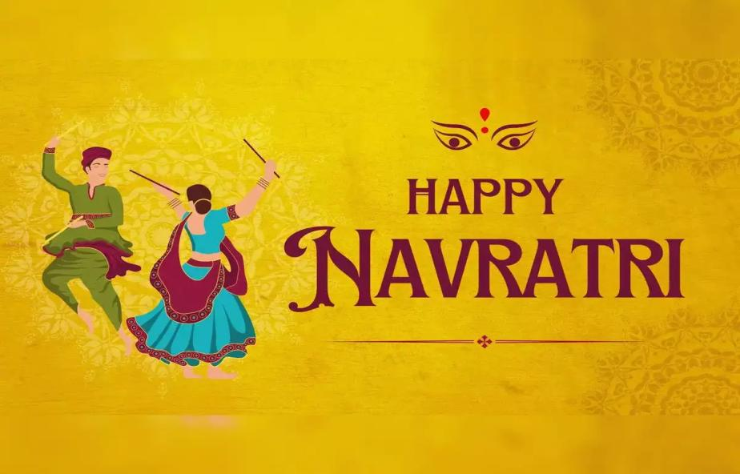

# **Navratri: Nine Nights of Divine Feminine Power**

## Introduction: A Celebration of Shakti and Devotion

**Navratri**, meaning “**nine nights**” in Sanskrit, is one of the most vibrant and spiritually significant festivals in Hinduism. Celebrated over **nine nights and ten days**, it honors **Goddess Durga** and her various forms, symbolizing the triumph of **good over evil**. Occurring typically in **September or October**, Navratri is marked by **fasting, prayers, music, dance (Garba/Dandiya), and dramatic performances**. It celebrates the **divine feminine energy** or **Shakti** that sustains and protects the universe.

## 

## Mythological Origins of Navratri

### Durga and Mahishasura

The most popular legend linked to Navratri is the **battle between Goddess Durga and the demon king Mahishasura**. Mahishasura, blessed with a boon that made him invincible to men, terrorized the heavens and earth. The gods, in desperation, combined their energies to create **Durga**, a fierce warrior goddess. After a fierce battle lasting nine nights, **Durga defeated Mahishasura on the tenth day**, celebrated as **Vijayadashami (Dussehra)**.

### Other Legends

* In **North India**, Navratri also celebrates **Lord Rama’s victory** over the demon Ravana.
* In **Bengal**, the focus is on **Durga’s visit to her maternal home**, symbolizing her motherly affection and power.

## Nine Days, Nine Forms of the Goddess

Each day of Navratri is dedicated to one of the **nine avatars of Durga**, collectively known as **Navadurga**:

1. **Shailaputri** – Daughter of the mountains
2. **Brahmacharini** – The ascetic goddess
3. **Chandraghanta** – The warrior goddess
4. **Kushmanda** – Creator of the universe
5. **Skandamata** – Mother of Skanda (Kartikeya)
6. **Katyayani** – Fierce and powerful form
7. **Kalaratri** – Destroyer of darkness
8. **Mahagauri** – Purity and serenity
9. **Siddhidatri** – Bestower of siddhis (powers)

Devotees worship each form with **specific colors, offerings, and prayers**, often fasting during the entire nine-day period.

## Dance, Music, and Cultural Festivities

### Garba and Dandiya Raas

In **Gujarat and Maharashtra**, Navratri is synonymous with **Garba and Dandiya**, traditional group dances performed around a central lamp or idol of Durga. Participants wear **colorful attire**, and dance through the night in joyous celebration.

### Ramleela Performances

In **North India**, especially Uttar Pradesh and Delhi, **Ramleela (dramatic reenactments of Ramayana)** are staged in public spaces, leading up to **Dussehra**, when effigies of **Ravana, Meghnad, and Kumbhkaran** are burnt to signify the destruction of evil.

## Regional Variations of Navratri

* **West Bengal (Durga Puja)**: The last five days of Navratri are celebrated as **Durga Puja** with elaborately decorated pandals, cultural events, and immersion of Durga idols on **Vijaya Dashami**.
* **Tamil Nadu**: Homes display **Golu dolls** in tiers, and women are invited for **haldi-kumkum ceremonies**.
* **Karnataka**: Known as **Dasara**, Mysore hosts a **royal procession** and grand cultural festivities.
* **Andhra Pradesh**: Celebrated with **spiritual discourses, music concerts**, and temple rituals.

## Fasting and Spiritual Practices

Devotees observe **various types of fasts**, ranging from fruits-only to specific vegetarian meals. Many read the **Durga Saptashati** (700 verses praising the goddess), visit temples, and perform **aarti** and **kanya puja** (worship of young girls as manifestations of the goddess).

The goal of fasting and prayer is to **purify the body and mind**, deepen spiritual focus, and receive the **blessings of Shakti**.

## Conclusion: The Power of Devotion and the Divine Feminine

Navratri is more than a religious celebration — it is a profound acknowledgment of the **feminine power that nurtures, protects, and transforms**. It teaches us to stand up against injustice, stay rooted in righteousness (dharma), and honor the divine energy present in all beings.

Whether through music, rituals, stories, or dance, Navratri kindles **devotion, community spirit, and inner strength**. As the festival ends with the victory of good over evil, it leaves behind a message of **hope, renewal, and the eternal presence of the goddess in our lives**.